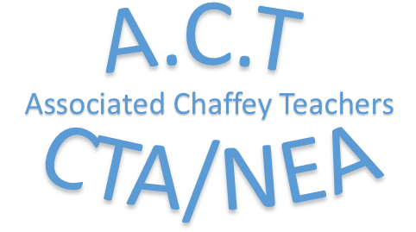

2020 Chaffey College Future Educator Scholarship

Eligibility
- Be a high school senior.
- Attend Chaffey College in the fall of 2020or the spring of 2021.
- Submit a completed application by the deadline – deadline – Thursday, April 2, 2020. Applications should be mailed to the following address:

Associated Chaffey Teachers
Attn: Scholarship Committee
337 N. Vineyard Ave, Suite #245
Ontario, CA 91764

- Have an unweighted high school GPA of 2.75 or higher. Please attach a transcript for verification.

Evaluation of Applications
- The applicant must submit an unofficial transcript for GPA verification purposes.
- The applicant must submit one letter of recommendation from a teacher familiar with their coursework.
- The applicant must complete a 250-500 word statement about why they want to attend Chaffey Community College, and how community college will prepare them in the first steps of being an educator.

Scholarship Amount: $500.00

All application materials must be postmarked no later than Thursday, April 2, 2020.
PLEASE TYPE OR PRINT ALL INFORMATION

APPLICANT’S NAME
- _______________________________ ____________________________________
FIRST NAME LAST NAME

APPLICANT’S MAILING ADDRESS
- ____________________________________________________________________________
STREET ADDRESS CITY ZIP CODE
APPLICANT’S EMAIL:
- ____________________________________________________________________________

APPLICANT’S PHONE NUMBER
- ____________________________________________________________________________
LETTER OF RECOMMENDATION: PLEASE ATTACH THE RECOMMENDATION TO YOUR COMPLETED APPLICATION.

Recommender 1: ____________________________________________________________________
Name Email or Phone Number

Recommender 2: ____________________________________________________________________
Name Email or Phone Number

250 WORD RESPONSE (ATTACH ADDITIONAL PAGES IF NECESSARY)
____________________________________________________________________________________________________________________________________________________________________________________________________________________________________________________________________________________________________________________________________________________________________________________________________________________________________________________________________________________________________________________________________________________________________________________________________________________________________________________________________________________________________________________________________________________________________________________________________________________________________________________________________________________________________________________________________________________________________________________________________________________________________________________________
____________________________________________________________________________________________________________________________________________________________________________________________________________________________________________________________________________________________________________________________________________________________________________________________________________________________________________________________________________________________________________________________________________________________________________________________________________________________________________________________________________________________________________________________________________________________________________________________________________________________________________________________________________________________________________________________________________________________________________________________________________________________________________________________

By signing below, I am acknowledging that I have submitted the following information: a completed application, a letter of recommendation from a colleague familiar with my work habits, and verification of my acceptance or application into an eligible program. I also acknowledge everything I have represented in this application is true to the best of my knowledge.

__________________________________________________________ ___________________
Name Date

